# Creacion y muestra de servicios DynamoDB aws con localstack

Comandos de creación de tablas:

aws --endpoint-url=http://localhost:4566 --profile default dynamodb create-table --table-name SegundaTabla --attribute-definitions AttributeName=Id,AttributeType=S --key-schema AttributeName=Id,KeyType=HASH --provisioned-throughput ReadCapacityUnits=5,WriteCapacityUnits=5

aws --endpoint-url=http://localhost:4566 --profile default dynamodb create-table --table-name SegundaTabla --attribute-definitions AttributeName=Id,AttributeType=S --key-schema AttributeName=Id,KeyType=HASH --provisioned-throughput ReadCapacityUnits=5,WriteCapacityUnits=5

Listo las dos tablas creadas:

aws --endpoint-url=http://localhost:4566 --profile default dynamodb list-tables

// Revisa la informacion de las tablas

aws --endpoint-url=http://localhost:4566 dynamodb scan --table-name PrimeraTabla

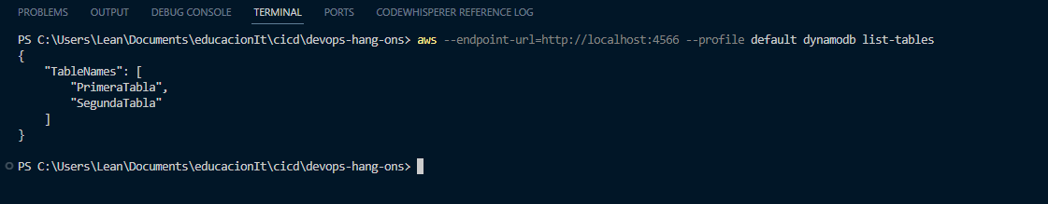

# Crear modulo terraform para levantar tablas DynamoDB en localstack

Generamos el archivo main.tf:

provider "aws" {

region = "us-east-1"

access_key = "1234"

secret_key = "1234"

skip_credentials_validation = true

skip_metadata_api_check = true

skip_requesting_account_id = true

endpoints {

dynamodb = "http://localhost:4566"

}

}

resource "aws_dynamodb_table" "primera_tabla" {

name = "PrimeraTabla"

billing_mode = "PROVISIONED"

read_capacity = 5

write_capacity = 5

hash_key = "Id"

attribute {

name = "Id"

type = "S"

}

}

resource "aws_dynamodb_table" "segunda_tabla" {

name = "SegundaTabla"

billing_mode = "PROVISIONED"

read_capacity = 5

write_capacity = 5

hash_key = "UserId"

attribute {

name = "UserId"

type = "S"

}

}

Ejecutamos los siguientes commandos:

terraform init

terraform plan

terraform apply

En caso de ser necesario, se deben eliminar las tablas pre-existentes

aws --profile default --endpoint-url http://localhost:4566 dynamodb list-tables

Adjuntamos captura:

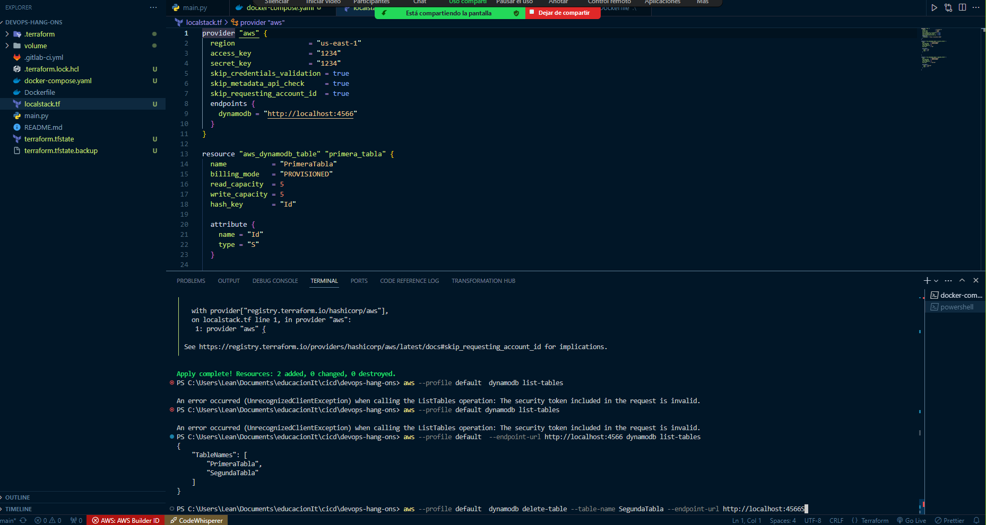

Crear servicio S3 en localstack

Se genera el archivo de configuracion .tf para crear los buckets y subir el recurso:

resource "aws_s3_bucket" "bucket1" {

bucket = "bucket1"

}

resource "aws_s3_bucket" "bucket2" {

bucket = "bucket2"

}

resource "aws_s3_object" "bucket1" {

bucket = aws_s3_bucket.bucket1.bucket

key = "prueba.txt" *# Nombre del archivo en el bucket*

acl = "private"

source = "./README.md" *# Ruta local del archivo que deseas subir al bucket*

}

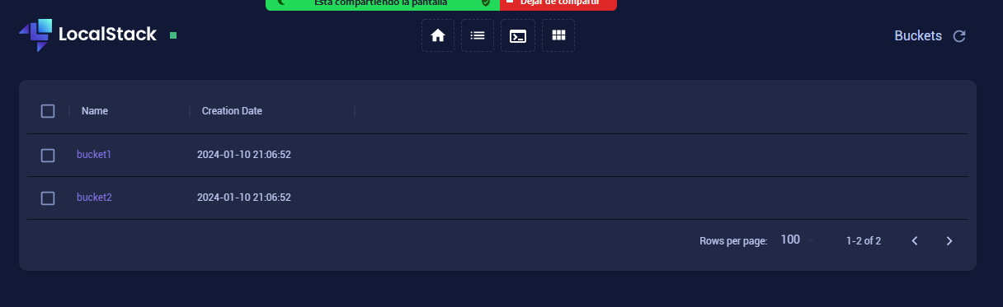

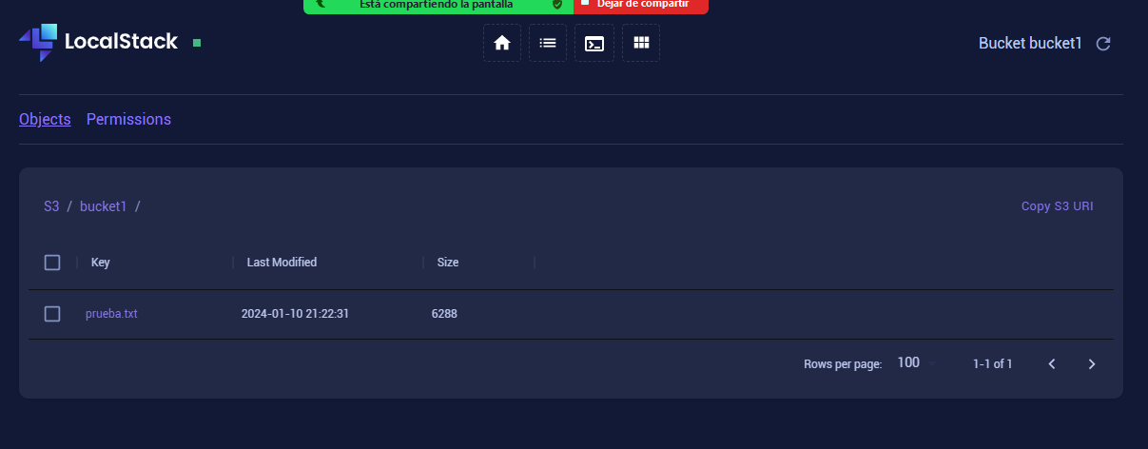

# Crear servicio EC2 en localstack

Se genera las EC2 y SQS según la documentacion del grupo 1:

resource "aws_security_group" "my_security_group" {

name = "my-security-group"

description = "Security group for my EC2 instances"

ingress {

from_port = 8000

to_port = 8000

protocol = "tcp"

cidr_blocks = ["0.0.0.0/0"]

}

}

resource "aws_instance" "app_server" {

ami = "ami-ff0fea8310f3"

instance_type = "t3.nano"

vpc_security_group_ids = [aws_security_group.my_security_group.id]

user_data = file("user_script.sh")

tags = {

Name = "ExampleAppServerInstance"

}

count = 1

}

resource "aws_sqs_queue" "tf_queue_one" {

name = "queue-one"

delay_seconds = 10

max_message_size = 2048

message_retention_seconds = 86400

receive_wait_time_seconds = 10

tags = {

Environment = "production"

}

}

resource "aws_sqs_queue" "tf_queue_two" {

name = "queue-two"

delay_seconds = 10

max_message_size = 2048

message_retention_seconds = 86400

receive_wait_time_seconds = 10

tags = {

Environment = "production"

}

}

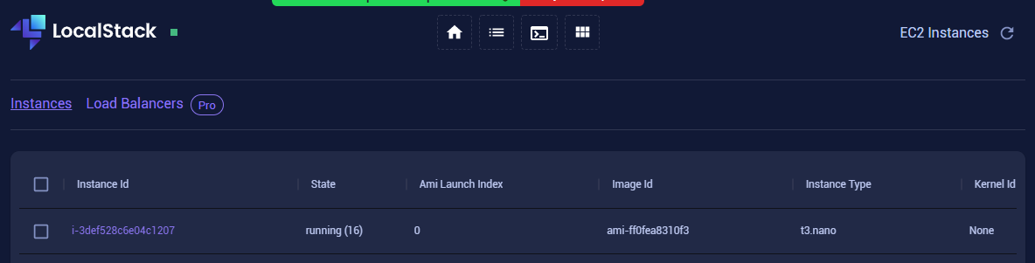

# Automation LocalStack

Se genera el siguiente codigo para levantar los servicios:

**import** boto3

**import** time

*# Configura el cliente de DynamoDB*

dynamodb_client = boto3.client('dynamodb', endpoint_url='http://localhost:4566')

*# Configura el cliente de EC2*

ec2_client = boto3.client('ec2', endpoint_url='http://localhost:4566')

*# Configura el cliente de S3*

s3_client = boto3.client('s3', endpoint_url='http://s3.localhost.localstack.cloud:4566')

**def** create_dynamodb_table():

table_name = 'tabla1'

attribute_definitions = [

{'AttributeName': 'id', 'AttributeType': 'S'},

]

key_schema = [

{'AttributeName': 'id', 'KeyType': 'HASH'},

]

dynamodb_client.create_table(

TableName=table_name,

AttributeDefinitions=attribute_definitions,

KeySchema=key_schema,

ProvisionedThroughput={

'ReadCapacityUnits': 1,

'WriteCapacityUnits': 1,

}

)

**print**(f'DynamoDB table {table_name} created.')

**def** create_ec2_instance():

instance_type = 't3.nano'

ami_id = 'ami-ff0fea8310f3' *# Replace with a valid AMI ID*

response = ec2_client.run_instances(

ImageId=ami_id,

InstanceType=instance_type,

MinCount=1,

MaxCount=1,

)

instance_id = response['Instances'][0]['InstanceId']

**print**(f'EC2 instance {instance_id} created.')

**def** create_s3_bucket():

bucket_name = 'bucket1'

s3_client.create_bucket(Bucket=bucket_name)

**print**(f'S3 bucket {bucket_name} created.')

**if** __name__ == "__main__":

*# Crea la tabla de DynamoDB*

create_dynamodb_table()

*# Crea la instancia de EC2*

create_ec2_instance()

*# Crea el bucket de S3*

create_s3_bucket()

*# Espera unos segundos para que los servicios estén completamente disponibles*

time.sleep(5)

**print**("Servicios creados exitosamente.")

